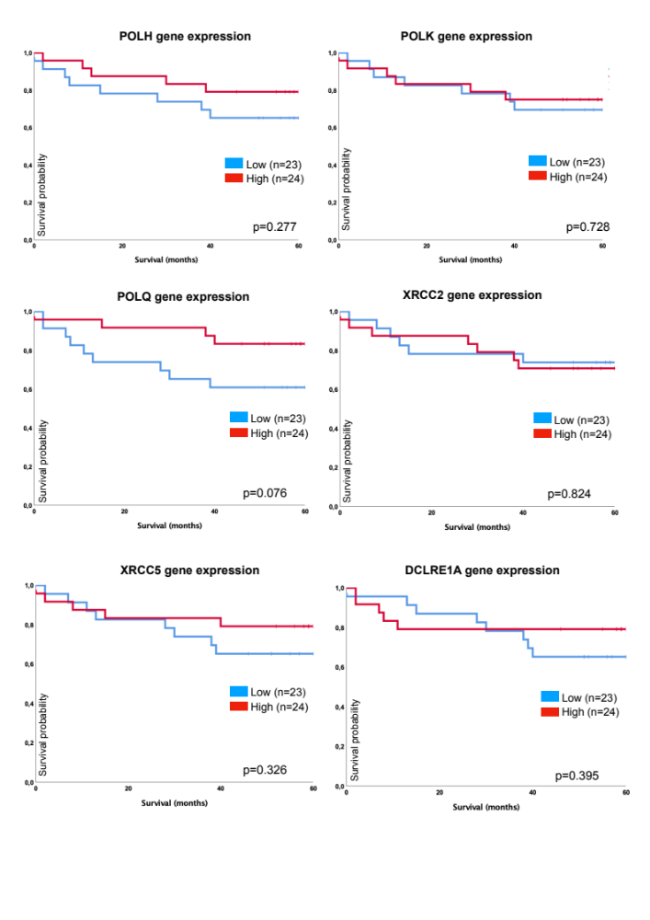
Supplementary Figure S1: Associations of overall survival of DNA repair gene expression of POLH, POLK, POLQ, XRCC2, XRCC5 and DCRLE1A utilizing Kaplan-Meier curve.

